🚀 Project Update: Installing Kubernetes Using Minikube on AWS 🚀

I'm excited to share my latest project where I successfully installed Kubernetes using Minikube on an AWS t3.small RHEL 9 instance. Here's a detailed guide on how I accomplished this, including creating a YAML file for Nginx replicas and scaling them.

1. Launching the AWS Instance:

* Instance Type: AWS t3.small
* OS: RHEL 9

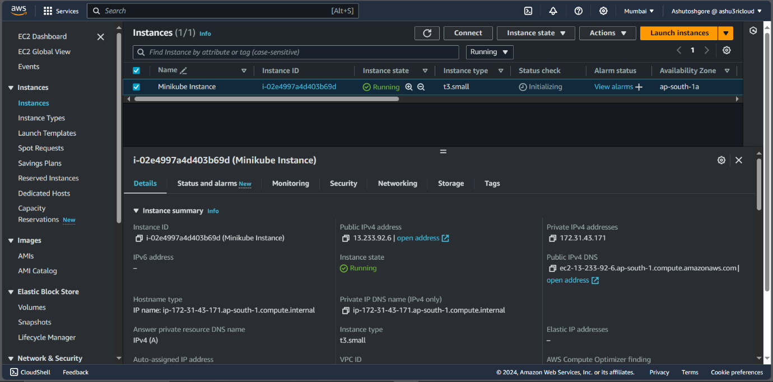

1. Setting Up the Environment:

* Installing Docker
  + yum install -y yum-utils
  + yum-config-manager --add-repo <https://download.docker.com/linux/rhel/docker-ce.repo>
  + yum install docker-ce docker-ce-cli containerd.io docker-buildx-plugin docker-compose-plugin
  + systemctl start docker
  + systemctl enable docker
  + systemctl status docker
  + 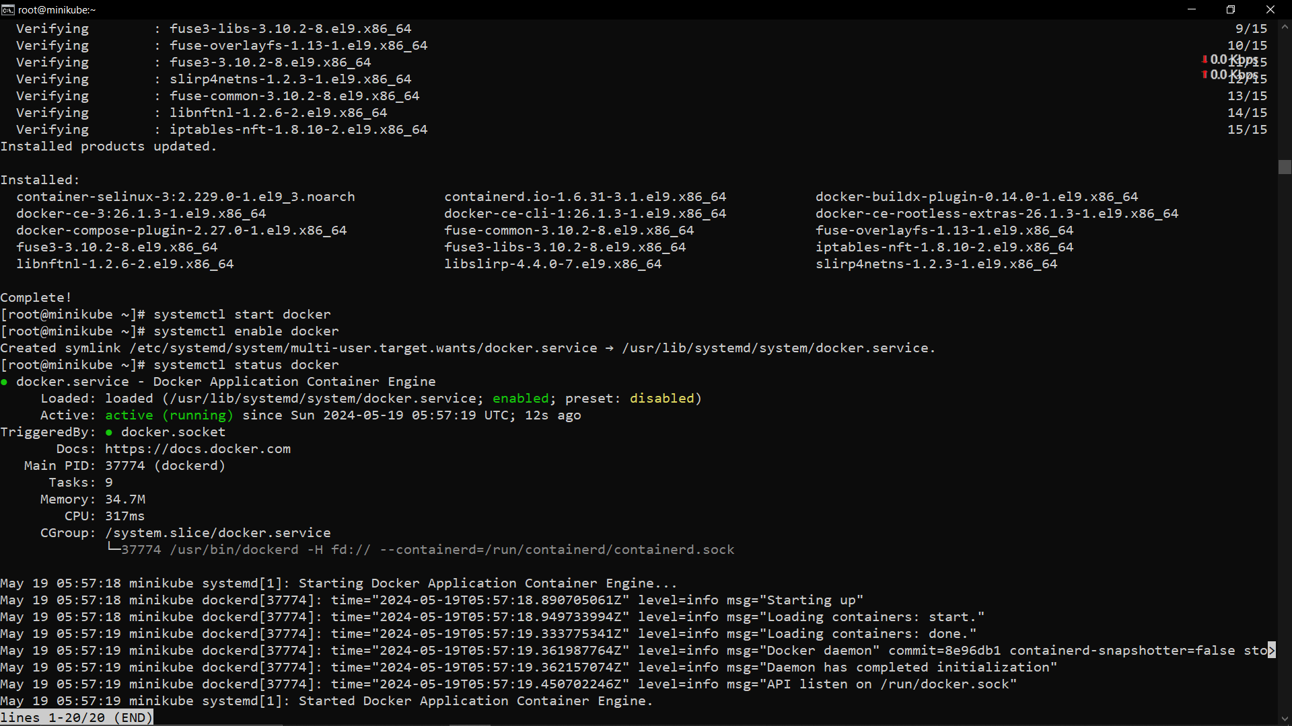
* Installing Vim
  + yum install vim -y
* Installing Minikube
  + curl -LO https://storage.googleapis.com/minikube/releases/latest/minikube-linux-amd64
  + install minikube-linux-amd64 /usr/local/bin/minikube && rm minikube-linux-amd64
  + minikube start --force
  + 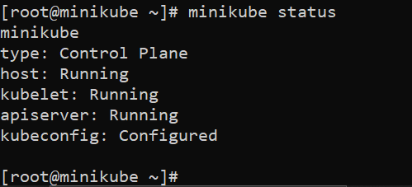

1. Starting Minikube

* Starting Minikube with Docker Driver
  + minikube start --force (here --force is used to use a docker with root privileges. This command will automatically pick docker)

1. Creating the YAML File:

* vim nginx-rs.yaml
  + 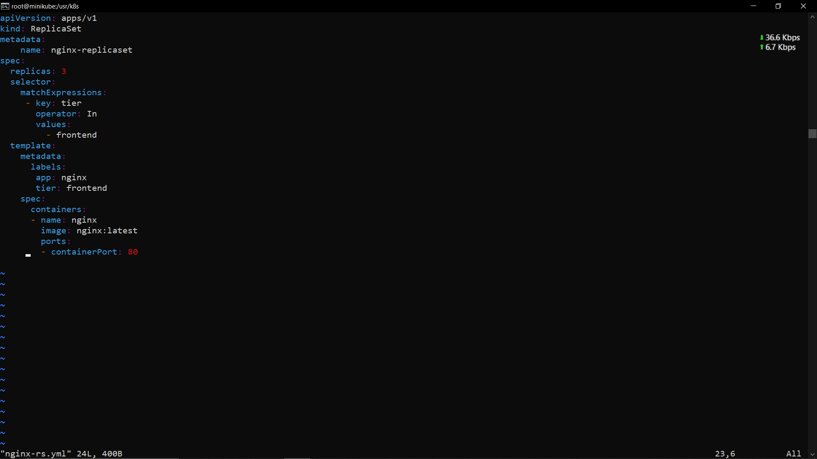

1. Deploying Nginx:

* Applying the YAML File
  + minikube kubectl -- apply -f nginx-rs.yml
* Verifying the Deployment
  + minikube kubectl get pod
* 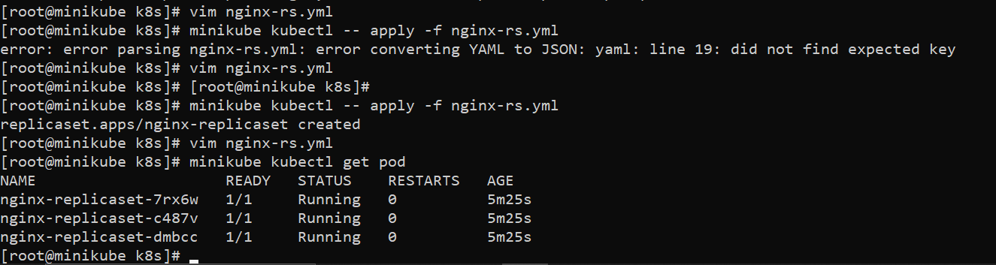

1. Scaling the Deployment:

* Scaling to 4 Replicas, and again scaling out to 1
  + Scaling to 4
    - minikube kubectl -- scale replicaset nginx-replicaset --replicas=4
  + scaling out to 1
    - minikube kubectl -- scale replicaset nginx-replicaset --replicas=1
* Verifying the Scaling
  + minikube kubectl get pod
* 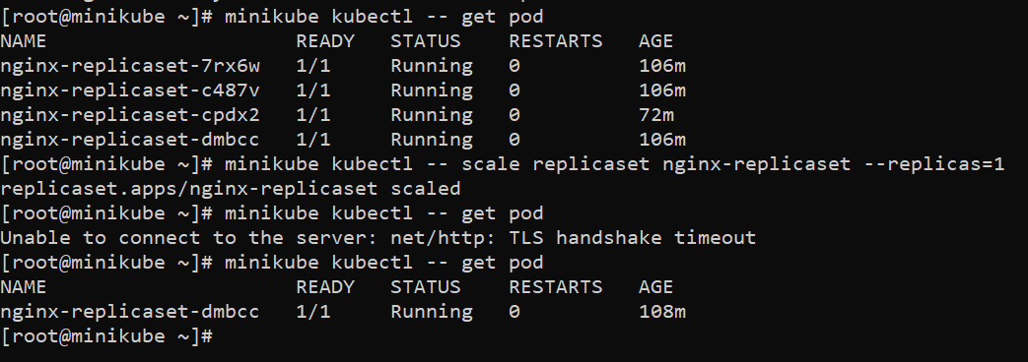

1. Success!

* Seeing the Nginx replicas scale seamlessly was incredibly rewarding. This project not only enhanced my understanding of Kubernetes but also demonstrated the power and flexibility of cloud infrastructure.